Case Study: Advantages of Using AI in the Manufacturing Industry


Rich Fox
ITAI 2372 – Artificial Intelligence Ethics
Houston Community College – Applied AI & Robotics Program
July 18, 2026

Introduction
Artificial Intelligence (AI) is transforming the manufacturing industry by enabling smarter, faster, and more efficient production processes. Modern manufacturing facilities generate vast amounts of data from machines, sensors, cameras, and enterprise systems, and AI technologies such as machine learning, computer vision, robotics, and predictive analytics help organizations convert this data into actionable insights that improve operational performance (Javaid et al., 2022; Lee et al., 2018).
Manufacturers are increasingly adopting AI to enhance quality control, optimize supply chains, reduce production costs, minimize waste, and improve workplace safety. One of the most significant applications is automated quality inspection, where computer vision systems identify defects with greater speed and consistency than human inspectors. By catching problems earlier in the production process, manufacturers reduce rework costs, improve product quality, and increase customer satisfaction (Microsoft, 2024).
This report examines a real-world case study of BMW's use of AI-powered visual inspection for quality control, then proposes an innovative AI application aimed at reducing material waste through computer vision and machine learning optimization. I selected material waste reduction because many manufacturers already invest heavily in quality control systems. Extending existing computer vision infrastructure to reduce scrap appears to be a practical way to generate additional value from technology that is already in place.

Case Study Analysis: BMW's AI-Powered Visual Inspection System

Background and Problem Statement
In automotive manufacturing, maintaining consistent quality across thousands of vehicles is a major challenge. Modern vehicles consist of thousands of components, and even minor defects such as scratches, alignment errors, missing parts, or incorrect badges can result in customer complaints, warranty claims, and costly rework.
Traditionally, quality inspections relied heavily on human inspectors. Experienced workers are highly skilled, but manual inspection can be affected by fatigue, varying judgment, time constraints, and the sheer complexity of modern vehicle configurations. BMW recognized the need for a more reliable and scalable quality assurance system capable of identifying defects quickly and accurately across its production facilities, one that would improve inspection accuracy while supporting its broader digital manufacturing strategy, known as the BMW iFACTORY (Axis Communications, 2024; Aicadium, 2023).

AI Technologies and Tools Used
BMW implemented AI-powered visual inspection systems that combine computer vision, deep learning, cameras, sensors, and large image datasets.

Computer Vision
Computer vision technology enables machines to "see" and interpret visual information from cameras positioned throughout the assembly line. These cameras continuously capture images of vehicles and components as they move through production (Axis Communications, 2024; Aicadium, 2023).

Deep Learning Models
BMW's quality inspection platform uses deep learning algorithms trained on millions of images and production data points. These models learn to recognize patterns associated with correct assemblies and identify deviations that may indicate defects, including scratches or dents, missing components, improper assembly, incorrect vehicle badges, alignment problems, and design flaws. The AI compares real-time production images against approved reference standards and automatically flags abnormalities (Axis Communications, 2024; Aicadium, 2023).

AIQX (Artificial Intelligent Quality Next)
BMW developed its proprietary AIQX platform to support automated quality control throughout vehicle production. The platform integrates image data, vehicle localization information, and AI analysis to perform highly automated inspections within fractions of a second, managing image collection and processing while providing actionable quality insights directly to production teams (Axis Communications, 2024).

Smart Cameras and Sensors
Network cameras positioned along production lines continuously capture vehicle images. The system synchronizes camera data with the location of each vehicle, ensuring accurate component inspection at every assembly stage (Axis Communications, 2024).
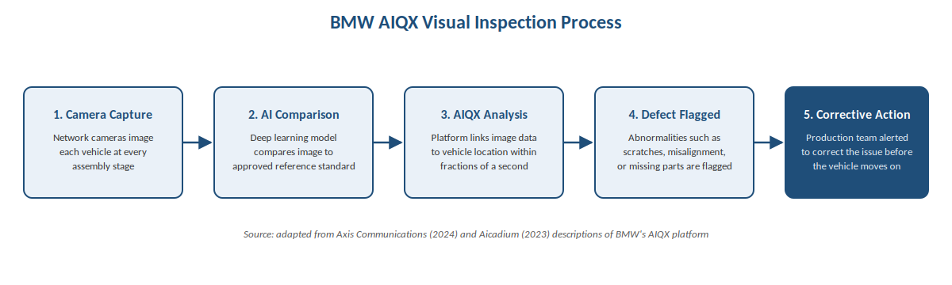
Figure 1. BMW's AIQX visual inspection process, from camera capture to corrective action.

Implementation Process
BMW began integrating AI technologies into manufacturing operations around 2018 as part of its broader digital transformation strategy. The company adopted a phased implementation approach, initially introducing AI for specific inspection tasks before expanding its use across production operations (Aicadium, 2023). The implementation process included collecting large volumes of image data from production lines, training AI models using reference images of correctly assembled vehicles, installing cameras and sensors throughout manufacturing facilities, integrating AI systems into existing quality management workflows, and continuously retraining models based on new production data and observed defects. This gradual, staged rollout allowed BMW to validate system performance while minimizing disruption to ongoing manufacturing operations.

Outcomes and Benefits Achieved
What stands out most is that BMW is not replacing inspectors entirely. Instead, the company is using AI to help workers find defects more consistently. This approach is likely more practical than attempting full automation because human expertise is still valuable when unusual issues occur. AI systems can identify subtle visual inconsistencies that may be difficult for human inspectors to notice consistently, and unlike human workers, they do not experience fatigue, so inspection quality stays the same throughout continuous operation (Axis Communications, 2024; Aicadium, 2023).
The AIQX platform performs inspections in real time while vehicles move through production, with automated analysis flagging defects within seconds, far faster than manual methods can achieve (Axis Communications, 2024). By automating repetitive inspection tasks, BMW also frees employees to focus on more complex, value-added work, and faster inspections help maintain production flow rather than creating bottlenecks on the assembly line (Aicadium, 2023).
These improvements compound into better product quality overall. AI-driven quality control improves manufacturing consistency and reduces the likelihood of defective vehicles reaching customers, since early detection enables corrective action before problems become more expensive to fix later in the process (Axis Communications, 2024; Aicadium, 2023). The AIQX platform also generates valuable production data that engineers can analyze to identify recurring quality issues and process improvement opportunities (Axis Communications, 2024), and the whole system supports BMW's iFACTORY strategy for building highly connected, intelligent manufacturing environments (Axis Communications, 2024; BMW Group, 2025). In the automotive industry, even a small quality issue can result in expensive warranty claims or customer dissatisfaction. Detecting defects earlier in production is therefore important not only for quality but also for profitability.

The table below summarizes how BMW's AI-powered inspection compares to the manual process it was designed to strengthen.

Factor | Manual Inspection | BMW's AIQX System
Consistency | Varies by inspector, shift, and fatigue level | Consistent every inspection, every shift
Speed | Limited by human reaction time | Defects flagged within seconds, in real time
Defect detection | Can miss subtle scratches, alignment errors | Trained on millions of reference images
Cost impact | Late-stage catches are the most expensive | Early detection lowers rework and warranty cost
Scalability | Adding capacity means hiring/training staff | Scales across plants once models are trained

Challenges and Risks Encountered
Despite its success, BMW faced several real challenges in implementing AI-powered quality control. Deploying AI infrastructure requires substantial investment in hardware, software, cameras, sensors, data storage systems, and employee training, costs that smaller manufacturers may find difficult to justify initially. AI models also require vast amounts of high-quality labeled image data for training, and collecting, organizing, and maintaining that data is time-consuming and resource-intensive.
Integrating AI systems with existing manufacturing equipment and enterprise software can be technically challenging, since legacy systems often require significant modification to support advanced AI applications. Once deployed, models must be continuously updated as new vehicle designs, components, and production processes are introduced, and regular retraining is what keeps accuracy high over time. Finally, as manufacturing systems become increasingly connected, cybersecurity risk grows alongside them, meaning organizations must actively protect production data and AI systems from unauthorized access. Even so, BMW's successful deployment demonstrates that the benefits of AI-powered quality control can significantly outweigh these implementation challenges when they are managed effectively.

Proposal for Innovation: AI-Powered Waste Reduction System

Manufacturing Challenge: Material Waste on BMW's Assembly Line
Quality control is not the only place AI can add value on BMW's production floor. Before a vehicle reaches the AIQX inspection stations described above, its body panels begin as raw sheet steel and aluminum that must be cut and stamped into shape earlier in the same assembly line. This stamping stage is a significant source of material waste: inefficient cutting layouts, inaccurate forecasting, setup errors, and inconsistent processes all cause usable material to be discarded before a vehicle is assembled. Even a small improvement in material utilization here could save BMW a meaningful amount in raw material costs each year, while also reducing its environmental footprint. The same underlying challenge also affects other manufacturing industries such as textiles, woodworking, packaging, and plastics production, but BMW's own stamping operations are a logical place to start given the material volumes already involved in vehicle production.

Proposed AI Solution
I propose extending the same computer-vision infrastructure BMW already uses for AIQX quality inspection into its stamping operations, where body panels are cut from sheet steel and aluminum before final assembly. This AI-powered waste reduction system would combine computer vision, machine learning, and optimization algorithms to identify waste patterns on the stamping line in real time and recommend improved cutting and material layout strategies. The system would consist of four core components: computer vision cameras that monitor the stamping line and capture images of raw sheet stock, cutting patterns, scrap, and finished panels; machine learning models that analyze production data to identify recurring waste patterns and root causes; an optimization engine that generates more efficient cutting layouts to maximize material utilization; and a real-time dashboard that gives operators live recommendations and performance data to support decision-making.

How the System Works
On BMW's stamping line, cameras would continuously capture images of sheet steel and aluminum stock before cutting begins, alongside relevant production data such as dimensions, material type, orders, and scrap quantities. Computer vision models would then identify unused portions of material and classify waste into categories such as cutting waste, defective panels, excess trim material, and setup-related waste. From there, machine learning algorithms would analyze historical waste data to surface trends and recurring inefficiencies, for example, certain body panel designs consistently generating excessive scrap, specific shifts producing more waste than others, or certain stamping presses showing higher loss rates. Based on these findings, the AI system would generate improved material layouts that maximize usable surface area and minimize scrap, and the model would continually learn from new production outcomes, improving its recommendations over time, much the same way BMW's AIQX models continue to learn from new defect data.
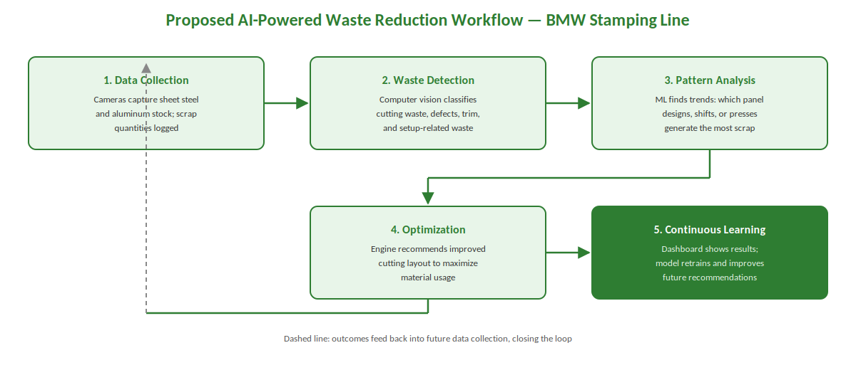
Figure 2. Proposed AI-powered waste reduction workflow for BMW's sheet-metal stamping and cutting line, from data collection through continuous learning.

Potential Benefits
Even a small reduction in stamping waste can generate significant financial savings, particularly given how much sheet steel and aluminum BMW purchases each year. By reducing raw material consumption and landfill waste, the system also supports environmental sustainability initiatives and corporate ESG goals. Optimized material layouts improve productivity by increasing output from the same amount of raw material, and real-time dashboards give managers detailed insight into waste generation and production efficiency that manual tracking simply cannot match. For BMW specifically, this would mean extending value from an infrastructure investment it has already made in computer vision and AI for AIQX, rather than starting a new technology initiative from scratch. Taken together, manufacturers that use AI to reduce waste can achieve lower operating costs and improve profit margins while meeting rising sustainability expectations.

Anticipated Challenges
Accurate recommendations depend on high-quality image and production data, so poor data collection practices would reduce system effectiveness. Installing cameras, sensors, and AI software also requires real upfront investment, and workers would need training to understand and trust AI-generated recommendations rather than falling back on old habits. Manufacturers may additionally face challenges connecting AI systems to older machines and production management software that was not designed with this kind of integration in mind. Despite these challenges, the long-term benefits strongly support implementation, particularly for manufacturers seeking cost savings and sustainability improvements.

Conclusion
Artificial Intelligence is rapidly changing manufacturing by improving efficiency, product quality, and operational decision-making. BMW's implementation of AI-powered visual inspection demonstrates how computer vision and deep learning can significantly enhance quality control by detecting defects more quickly and accurately than traditional manual inspection, and the company's AIQX platform illustrates the value of combining cameras, machine learning, and automated analytics within a smart factory environment.
Building on these developments, the proposed AI-powered waste reduction system offers another promising application of AI in manufacturing. By using computer vision and machine learning to identify waste patterns and optimize material layouts, manufacturers can reduce costs, improve sustainability, and increase production efficiency using much of the same underlying technology BMW already relies on for quality control.
As AI technologies continue to mature, organizations that successfully integrate intelligent systems into their operations will be better positioned to achieve higher productivity, stronger competitiveness, and long-term growth in the global manufacturing market.

References
Aicadium. (2023, December 13). How BMW is using AI to improve its manufacturing processes. https://aicadium.ai/how-bmw-is-using-ai-to-improve-its-manufacturing-processes/
Axis Communications. (2024). Axis cameras support innovative quality inspection in BMW Group vehicle production. https://www.axis.com/customer-story/axis-industrial-vehicle-production
BMW Group. (2025, April 28). Artificial intelligence as a quality booster. BMW Group PressClub. https://www.press.bmwgroup.com/global/article/detail/T0449729EN/artificial-intelligence-as-a-quality-booster
Javaid, M., Haleem, A., Singh, R. P., Khan, S., & Suman, R. (2022). Artificial intelligence applications for industry 4.0: A literature-based study. Journal of Industrial Integration and Management, 7(1), 83–111.
Lee, J., Davari, H., Singh, J., & Pandhare, V. (2018). Industrial artificial intelligence for industry 4.0-based manufacturing systems. Manufacturing Letters, 18, 20–23.
Microsoft. (2024). AI in manufacturing: Transforming operations with intelligence. Microsoft Industry Reports. https://www.microsoft.com/en-us/ai/manufacturing

